One man's response to “The Price of Land”, an uncritical feature article by Gary Shipway providing a platform for views of the Gwalwa Daraniki Association and its President Helen Secretary, published in The Northern Territory News, Saturday Extra, pages 18 & 19, August 12, 2017.

GARY SHIPWAY REPORTS - “THE PRICE OF LAND: One family's war to develop a patch of Darwin has left its battle scars. But the fight for the people of Kulaluk is not yet over...”
[this was the heading of a three-page report with full-page photo of an angry looking Helen Secretary on the cover].
Battle-weary but undaunted – A battle over land in the centre of Darwin has raged for decades. Last month, the war reached a definitive crossroads, with the Gunner Government ruling the area would not be heritage listed, thus paving the way for the future development. However, the custodians of the land still have a fight on their hands. GARY SHIPWAY reports” [subheading and introduction to the special News Feature across pages 18 and 19 on August 12, 2017].
Helen Secretary is tired. She's tired of fighting against her own people, tired of being disrespected as a custodian of Aboriginal land by “so-called environmentalist and heritage people”.
Ms Secretary is the chairman of the Gwala [sic] Daraniki Association which holds the Kulaluk and Minmarama Special Purposes leases in Darwin.
The association is made up mainly of the Secretary family and extended relatives at Kulaluk – a small pocket of land in Coconut Grove where about 50 people live in nine houses and a few bedsitters.
Her people want to develop the land they have for retail, industrial and residential use.
Kulaluk was the first piece of urban land returned to an Indigenous community. It was given back by former Chief Minister Paul Everingham in 1979, following a court battle for land rights over parts of Darwin that resulted in the granting of special purpose leases over areas including Bagot Community, One Mile Dam, Kulaluk and Minmarama.
By developing the land between the Darwin suburbs of Ludmilla and Nightcliff, the Gwala [sic] Daraniki Association would have money for new houses on the Kulaluk and Minmarama communities and, hopefully, surplus to fund an aged care facility.
They would be able to control their own destiny and shake free of the shackles of government dependence, Ms Secretary says.
It's a plan that has faced many hurdles, with court challenges and battles on heritage and environmental fronts.
The hurt and pain is obvious in Ms Secretary's voice as she talks about the long years battling against outsider interest groups that wanted a say in the land's future.
“This is our home,” she says.
“We Just want to be left alone to live in peace, but instead we have had to fight government and attempts to use heritage listing to stop us (developing).”
She was referring to attempts to have the Kulaluk Lease Area declared as a heritage place – a process which has dragged on for years.
“It started off back in 1993 when my grandmother was alive … I argued with the heritage office and Aboriginal Protection Authority, but they disrespected me as a custodian by saying they knew better,” Ms Secretary said.
The Aboriginal Areas Protection Authority is the independent statutory authority set up under the Northern Territory Aboriginal Sacred Sites Act to protect Indigenous sacred sites on land and sea across the whole of the Territory.
But all this talk of heritage has nothing to do with Aboriginal people, Ms Secretary says.
“That's white people's language. Heritage is white man's heritage, where they can go and heritage list Captain's Cook's cabin,” she says.
“For years we have suffered because of all the hurdles put in front of us, stopping us from moving forward and making out association better by economically opening up our land for employment, housing and our kids education.”
She spoke of the war waged to stop her organisation developing the land – a contradictory battle with the other side arguing the area should be heritage listed due to it being Larrakia land.
“We have had all these objections against us from the Environmental Defenders Office, supporting Larrakia nation [sic] and interfering with the Gwala [sic] Daraniki Association,” she says. “Our old people were Larrakia people. I had to put up with a white defenders office disrespecting my knowledge when I have lived on this land since a child. We have had nothing but hurdles unfairly put in our way.
“It was wrong to try and heritage (list) our land. We were put through hell. I was raised on this land.”

David Morris, principal lawyer at the Environmental defenders Office represented Larrakia Nation woman Donna Jackson in the Supreme Court fight to stop the Gwala [sic] Daraniki Association from going ahead with its plans for industrial and retail development on Kulaluk.
Mr Morris and more than 200 other people and organisations who made public submissions helped persuade the NT Heritage Council to recommend the land be protected.
“Kulaluk is centre stage for on of the most fascinating stories in the Territory's history, the struggle for land rights,”Mr Morris said during the battle.
“It's culturally important and environmentally just has an incredible value to the city. There's not may other places you can walk and see a jabiru before breakfast.”
Despite the protests, last month the Gunner Government decided not to proceed with the heritage listing. Environment Minister Lauren Moss said at the time: “After considering the matter carefully, I can confirm the site will not be permanently declared as a heritage place on the basis that it can be appropriately preserved and protected under existing provisions, without the need to rely upon such a declaration.”
Ms Moss' announcement came at the conclusion of years of difficulty getting custodians' hopes to be heard, Ms Secretary says.
“We were very happy when the Northern Territory Government signed a Memorandum of Understanding with the Gwala [sic] Daraniki Association in 2015,” she said. “At last we thought we were going to be able to unlock the economic potential of our land but then the new government decided to hold us up.”
Last year the former Country Liberals Land Minister David Tollner declined to declare the Kulaluk lease area as a heritage place. However, the Gunner Government decided to revisit that decision upon coming to office last September.
Mr Tollner said last month's decision by the Gunner Government not to proceed with the heritage listing vindicated his original decision. “For too long governments have been reluctant to hand indigenous people full control of their own lands,” Mr Tollner said. “The most effective way we can honour the importance of the lease is by allowing the GDA to determine how their lands will be developed. A heritage listing would prevent future development and would not protect any historical association with the Aboriginal land rights movement.”
Ms Secretary said GDA members were just hoping they would now be allowed to move on with their lives.
“The GDA will now have the chance to break the cycle of welfare dependency and provide more income and jobs for the communities of Kulaluk and Minmarama,” she says. “We want to use our land … we will not sell it. We will lease it and we will crate jobs for Aboriginal people, build new houses. We want to improve the living conditions and quality of housing for the people of out community. We want to get our young people trained. We want to give them better opportunities in life which this heritage fight has held up. We have young people that have certificates in civil construction, plumbing, roofing, administration and yet we just do not have any funds. It's about our people's future and their kid's futures.
“This win is not about clearing the way for bulldozers to destroy our land. It is about sensible redevelopment and doing it the right and proper way … If it's okay for the wider non-Indigenous people to buy land, build a home, or start a business and make a living out of it, why can't we?”
“Our association has 300 hectares of land and we want to use that for the benefit of our community and our people. We want to take responsibility for own own future. We just want a fair go.”

Ms Secretary still doesn't believe the fight is over. She has fired a broadside at the new Chair of the Northern Territory Planning Commission, Dr David Ritchie.
She said it would inappropriate for Dr Ritchie to have any role in a future that related to development plans involving the Kulaluk lease area. Dr Ritchie was the author of a report that advocated Ms Moss and the Gunner Government declare the Kulaluk Lease Area in Darwin as a heritage place.
“We see his report as hostile to what we argued on behalf of out people so it would be hard to expect him to change his position,” she said.
“So we believe he cannot have any involvement in the future with Gwala [sic] Daraniki Association plans … I would hope he excludes himself fro anything relate to Gwala [sic] Daraniki in the interests of impartiality.”
A spokesman for Planning Minister Nicole Manison said page 89 of the Planning Act had very clear guidelines relating to conflicts of interest which should allay concerns. However, for Ms Secretary, the battle won't be over until the first bricks of the association’s self-determined development are laid on their own land.

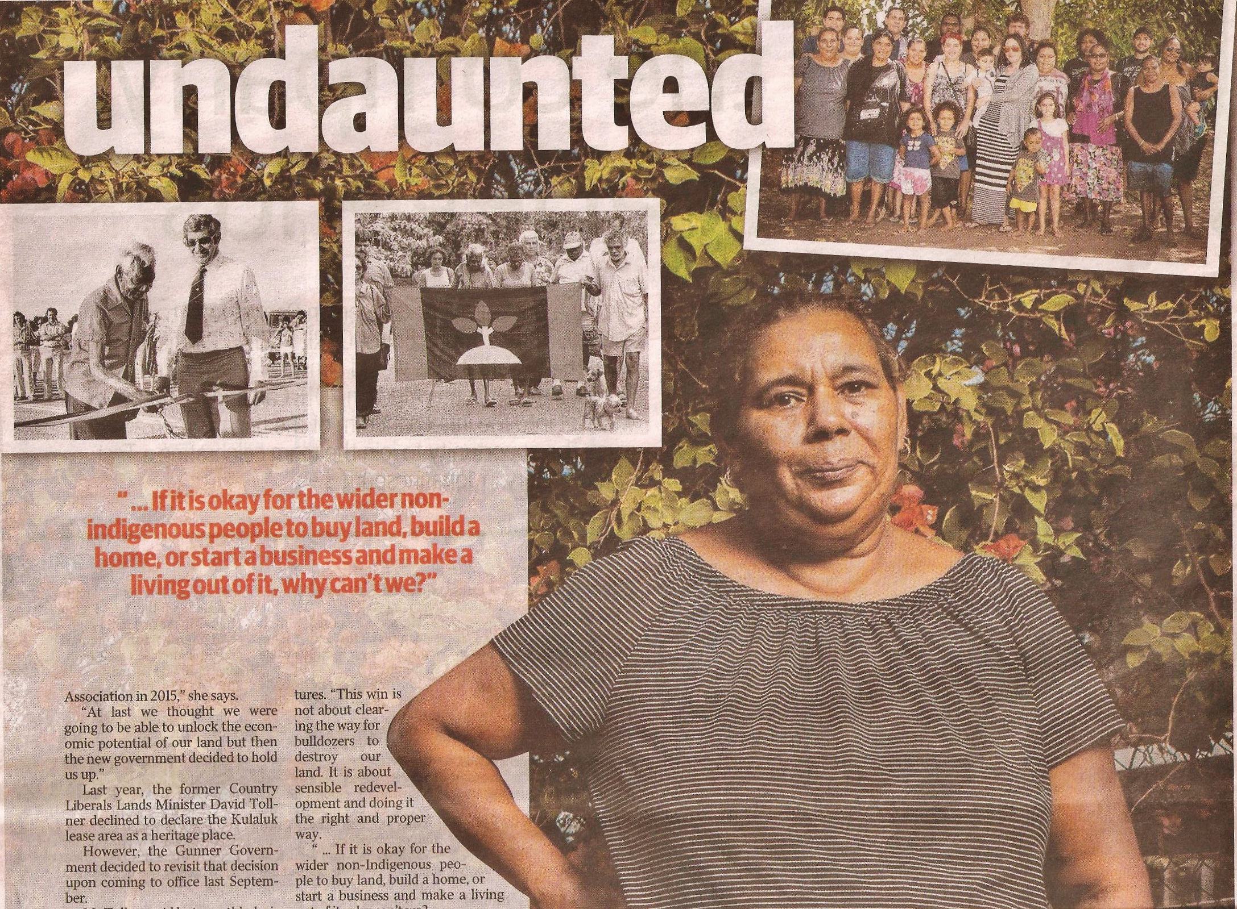
Above: Helen Secretary pictured on page 19 of News Feature, Saturday August 12, 2017. Photos left to right are Bobby Secretary (Helen's Great Uncle) opens Dick Ward Drive; Larrakias celebrate 25th anniversary of flag raising to claim Darwin; presumably the small clan eligible to be members of GDA.

Comment by Dr Bill Day: Gary Shipway rewrites history for Helen Secretary. The heading is revealing, “One family's war to develop a patch of Darwin...” the heading is an indication of the membership of the lease holding association which is restricted to a Larrakia clan, named but not defined in the association's constitution. Judge Mansfield's report on the Larrakia Native Title shows that there is no agreement amongst Larrakia on the membership of this clan; however the membership of the Gwalwa Daraniki Association is further restricted by the requirement that members should have lived on the lease for no less that 12 months. A quorum is “no less than five”, of which half must be Aboriginal. Non-Aboriginal spouses are eligible to be members, a concession that has greatly influenced the association in the past.
Shipway reports that Helen Secretary is tired of being disrespected as a custodian of Aboriginal land. Sighted documents and newspaper reports reveal Ms Secretary has abrogated rights to the land to Planit Consulting, Citiland/Jape, McDonalds Restaurants, Gwelo Construction, and Ernie Chin's Dragon Lady P/L. Other agreements appear to exist between the association and Halikos Construction, illegal dumpers behind Minmarama Village, developers of a failed prawn farm aquaculture project and a shared responsibility agreement with the federal government to develop a crab farm on the failed prawn farm site. In some cases these agreements last for 99 years, alienating the land for generations. In addition, Aboriginal Areas Protection Authority (AAPA) letters suggest Ms Secretary was used as a consultant to clear land of sites, despite their own records showing that sites exist in the area to be cleared.
During a hearing into rezoning an important historical and cultural site, Ms Secretary disputed the evidence of a senior Yolngu elder who submitted a report that a ceremonial site existed between Dick Ward Drive and Harney Street, behind the Bagot community. Ms Secretary was filmed arguing heatedly with senior Larrakia man, Eric Fejo at a community meeting in Fitzer Drive. She has also rejected the testimony of her elders in ABC TV news reports and on film has requested police to remove senior Larrakia women from the lease. In every case Ms Secretary has taken the side of developers who planned to destroy environmentally and culturally important sites, which included in the case of Gwelo/Arafura Harbour, almost the entire mangrove system. The evidence suggests that Ms Secretary can claim to be “custodian” only in regards to these and similar agreements, including with AAPA, and not as custodian as defined by Aboriginal customary law.
Helen's opponents are not just “so-called environmentalist and heritage people”. The record speaks for itself. As recorded in David Ritchie's report, the struggle for Kulaluk was a spearhead in the land rights movement and the passing of the Land Rights Act that has influenced the future of the Northern Territory and Australia as a whole. The transcripts of the Kulaluk land claim before Justice Dick Ward show that preservation of sites and the environment were the main motivators of the claim, including the fact that the land was once part of the of Bagot Aboriginal Reserve and contains over two hundred grave sites.
Shipway admits that: “The association is made up mainly of the Secretary family and extended relatives at Kulaluk” and that the total number residing in the small community is about fifty. Nowhere does he record the number who are members of the association. The community is hemmed in by multi-storey units in suburban Coconut Grove. The members are not the main users of the wider lease area and are rarely seen on it. Very few of the residents of the Minmarama Park Community on the lease would be eligible to be members. As revealed by investigations into a fatal house fire at the Kulaluk community, many residents pay rent for substandard accommodation and do not belong to the secretive clan.
Shipway writes that the 301hectare lease was granted by Paul Everingham in 1979 after “a court battle for land rights over parts of Darwin”. He does not mention that the hearings before the Interim Aboriginal Land Commissioner came after eight years of protest action, recorded in my book, “Bunji: a story of the Gwalwa Daraniki Movement” (ASP 1994). The decision to return the land had already been announced by Ian Viner, the Federal Minister for Aboriginal Affairs in April 1978 but the handover was delayed until after NT self government in July 1978. When Special Purpose Leases were granted over urban blocks in 1979, including granting the Kulaluk land to the Gwalwa Daraniki Association Inc, the association's constitution allowed for membership for all Aboriginal people.
The article claims that by developing the land, the association would have money for housing. The evidence suggest otherwise, although the financial standing of the association is not known as financial reports have not been made for several years, despite the Associations Act requiring annual financial statements to be submitted.
In 1981 the GDA made an agreement to receive $78,000 dollars from Redco Real Estate to partner in the development of a canal housing estate over Ludmilla Creek. This agreement was voted down in a Special General meeting of GDA members and others at Kulaluk. Since that time, membership has been progressively restricted and all agreements with developers have been kept secret. As a result of court action in 2018 it became known that Arafura Harbour P/L had paid the GDA $1.17 million over several years following the signing of a caveat with the GDA.
The failure of the prawn farm and $2mil crab farm were attributed to bad management and had nothing to do with “interest groups” and “environmentalist”, although there would have been good grounds to oppose the excavation of 5ha of ponds on a salt pan used by Aboriginal people and a roosting site for migratory birds.
The reason the plans for Gwelo's Arafura Harbour subsequent massive marina and canal housing estate on Kulaluk land were thwarted was because of the wider public outcry once the secret negotiations were exposed by the media in April 2009. Despite her statement “We just want to be left alone”, Helen Secretary must understand that the public has a legitimate interest in plans for the use of 301 hectares of urban land bisected by a major arterial highway, and that Larrakia people have an interest in how their land is to be used, in particular if the land is to be alienated in the interests of a few.
Helen says “It started in 1993, when my grandmother was alive...” Helen claims when she was 23 years old the AAPA disrespected her as a custodian. No evidence is given; however, considering how many senior Larrakia were alive in 1993, Helen would have been culturally a very junior authority. Supreme Court transcripts and other evidence suggests she had a very disturbed domestic life at the time which influenced her decision making, which included at that time, a 99-year sublease to McDonald's.
Helen goes on to say that heritage has nothing to do with Aboriginal people, giving the example of “Captain Cook's Cabin”. The significance to Aboriginal people of the site of the Myall Creek Massacre, or the Rottnest Island Prison contradicts Helen’s racial viewpoint. Another example listed by David Ritchie is the site of the Gurindji walk-off. Ritchie also likens the significance of Kulaluk to Runnymede in England and Gettysburg in America. But then Helen did not even accept the evidence of Yolngu elder James Gaykamangu who presented lists of Yolngu people who assembled in Darwin in the 1950s for a culturally and historically important ceremony to support Larrakia claims.
Shipway claims that the battle to save Kulaluk was “contradictory” because the “environmentalists” were opposing the Gwalwa Daraniki Association to save Larrakia land. It should be remembered that the Environment Defenders Office was acting on behalf of Larrakia Nation, and all subsequent appeals were made on the Nation's behalf. It is hardly contradictory that a body with over 1,500 members should oppose decisions made about Larrakia land by an association with a restricted and undisclosed membership on Larrakia land.
Constantly throughout the feature article, Helen Secretary portrays the issue as a white versus black dispute. Shipway points out that more than 200 people made submissions to the Heritage Council. Whether those submissions “persuaded” the Heritage Council to recommend the land be protected is questionable. Two significant factors influencing the Heritage Council reassessment of the Larrakia Nation nomination were the Larrakia led appeal to the Tribunal and the subsequent historical analysis by Dr David Ritchie.
The past Minister for Lands and Planning, David Tollner is quoted by Shipway as saying, “For too long governments have been reluctant to hand indigenous people full control of their own lands.” The statement comes from the same Minister who has repeatedly said that he supports converting the prime land held by the Bagot Aboriginal Community into a “normal” suburb, against the wishes of the residents. It is likely therefore that a Memorandum of Understanding signed by the Gwalwa Daraniki Association and the Adam Giles government would have ensured the alienation of the 301 hectare lease from Aboriginal and community lease. Already large sections of the lease have been signed over to developers in two 99-year subleases. As it turned out, the MoU proved to be non-binding on the Gunner government elected in 2017, and therefore meaningless.
Helen told Shipway, “This win is not about clearing the way for bulldozers to destroy our land. It is about sensible redevelopment and doing it the right and proper way …” The evidence says otherwise: the association agreed to the excavation of two failed aquaculture projects on a salt pan that was the roosting ground of migratory birds at high tides. The five hectares of ponds also blocked access to the beach used by Aboriginal people from the Bagot Aboriginal Community and threatened the vast mangrove system that had been a major reason for the Kulaluk claim. As Nonie Sharp has written: “[The Larrakia] 1970 claim to a section of waterfront known as Kulaluk in the Darwin suburbs may well be the first claim to sea country made along the tropical coast of Australia. Larrakia memories of seascape carry intense feeling and emotion.”
In 2014 the GDA defended to the clearing of land adjacent to a documented burial ground and agreed to the dumping of storm water from Ernie Chin's proposed light industry estate into the lease. They also signed a caveat over the lease to Arafura Harbour who had plans to excavate the Ludmilla Creek and totally destroy the creek's mangrove habitat to make way for a canal housing estate and marina. The “sensible development” also includes a secret agreement to allow a construction company to stockpile a mountain of waste rubble from construction sites around Darwin and various proposals for Lot 5182 bounded by Bagot Road, Totem Road, Dick Ward Drive and Fitzer Drive. When anyone objects to these plans, some of which are of doubtful legality, affect the amenity of residents and are environmentally unacceptable, Helen Secretary responds, “It is none of your business!” She talks about “our people” without defining who they are. Gary Shipway answers this in his introduction, “One family's war to develop a patch of Darwin has left its battle scars.”
The transcript of the Kulaluk claim held before the Interim Aboriginal Land Commissioner, Judge Dick Ward makes clear that the intention was for the land to be held by a Larrakia Land Trust. As the Aboriginal Land Rights Commissioner Judge A E Woodward wrote (1974:Paragraph 295), “Finally, on the question of tenure, from my observations of the Gwalwa Daraniki it would not be a suitable organisation to have this land vested in it.”
Helen states, “We want to take responsibility for our own future.” Her attitude that the land is a commodity to be traded is completely against the principles which led to the land being returned to Larrakia and others. In the 1975 Kulaluk claim, Judge Ward commented: “I cannot see how they can get an economic potential out of it merely by taking over from the Government the leasing of land to Europeans, I think it is alien to their concept, are they not becoming, in effect, European capitalists? I do not want to see them become that...”
Finally, Helen Secretary fires a broadside at Dr David Ritchie, author of a report to the Heritage Council which presented supporting evidence for the declaration of the lease as a heritage site. Although Helen sees the Ritchie report as “hostile to what we argued on behalf of our people”, the Ritchie Report includes statements by nine Larrakia people in defence of the cultural, environmental and historical significance of the lease to Larrakia people and others. Those who recorded statements include Donna Jackson, Eric Fejo, Daphne Talbot, Victor Raymond, Tony Lee, Rodney Browne, Peter Browne, Mary Raymond, Kathy Williams, none of whom are eligible to be members of the leaseholding association as defined by the association's constitution.
While most Larrakia would celebrate the appointment of Dr David Ritchie as a top public servant overseeing planning in Darwin, Helen believes that he “cannot have any involvement in the future...” and hopes Ritchie will “exclude himself from anything related to Gwalwa Daraniki Association plans in the interests of impartiality.” However, it could be said it is hypocritical for Helen to complain of alleged bias when she has regularly acted as a cultural consultant for developers and the Aboriginal Areas Protection Authority in advising on the existence of sites on land for the proposed developments which she and her family would be beneficiaries. In the case of a historical ceremony site behind Bagot, Helen gave evidence to the Development Consent Authority that ridiculed the well-researched evidence of Yolngu elder, James Gaykamangu. In defining sites, it is more usual that tribal elders act as senior consultants, and certainly not a junior woman with an interest in the destruction of land that is known to be the site of hundreds of undocumented burials.
Shipway ends his feature article stating “for Ms Secretary, the battle won't be over until the first bricks of the association’s self-determined development are laid on their own land.” Whether collecting payments, sometimes referred to as “Blood Money”, from speculative developments on Aboriginal land is “self determination” is questionable. The article also fails to question any of Helen's protestations, ignoring the fact that the GDA is beholden to secret agreements with McDonald's Restaurants, Citiland/Jape, Ernie Chin's Dragon Lady P/L, Halikos Construction and Arafura Harbour. With a downturn in the economy, these secretive financial arrangements have begun to unravel with uncertain results for the future of the land granted after an eight-year struggle by Larrakia people and their allies.

